Automated Model for Construction and Demolition (C&D) Rubble Volume Quantification

Following disasters, whether natural or man-made, rapidly assessing the extent of damaged buildings is crucial for developing effecting emergency response plans.
— Inputs (previously collected)
- Aerial and satellite imagery: pre- and post-conflict high-resolution images from Google Earth covering the affected regions; Al Laylaki, Burj El Barajneh, Haret Hreik, Chiyah, Majdal Selem, Bint-Jbeil, Yaroun, Mhaibib, Bodai, and Baalbek. Google earth imagery typically ranges from 0.3 to 1m/pixel (not ideal for precise debris volume estimation)- see a remediation measure.
Orthorectification of Google map imagery: co-register all pre/post event images to a common base layer (such as the OpenStreetMap Building Footprints).
- Building information: building type (residential, commercial, institutional), number of floors, and estimated height.
- Spatial context: urban/rural classification using the Degree of Urbanization (DEGURBA) typology.
- Waste Generation Rates (WGRs): per building type, to estimate the composition of waste (e.g., concrete, metal, wood).
- Population and density metrics: to contextualize debris estimates and enable aggregation to neighborhood or municipal levels.
—Data preprocessing and Annotation
Imagery will first be co-registered and standardized to a common spatial reference system. Pre- and post-event images will be aligned to ensure accurate pixel-wise change detection.
If building footprints are not available, they will be delineated manually or extracted using automated edge detection in QGIS [Lyu et al. 2025; QGIS Development Team].
Selected regions will then be annotated manually using QGIS to create a labeled dataset comprising three classes:
- Collapsed buildings
- Partially collapsed
- Non-collapsed buildings
- Background
Buildings will be labeled as “collapsed” if they display clear indicators of structural failure—such as roof loss, discontinuous texture, or complete structural deformation. When visible, collapsed areas will be further differentiated into partially and totally collapsed zones to improve model granularity.
  - If the original aerial images were too large to be directly processed by the deep learning model, divide each image into smaller patches of 512x512 pixels with a stride of 256 pixels- patches containing only background were discarded.
  - Data augmentation using Random Horizontal Flipping and Random Gaussian Blur.
  - Division of the training and testing datasets – training (70%), validation (10%), and testing (20%) subsets to prevent spatial overfitting -employ AdamW optimizer and adopt a poly learning rate schedule, initial learning rate set to 10⁻⁴. Around 10% of the training dataset is randomly selected as validation dataset. Batch size set to 32, train the network for 200 epochs. Set an early stopping criteria and conduct all runs with a fixed random seed of 2333. (all these variables are subject to change)
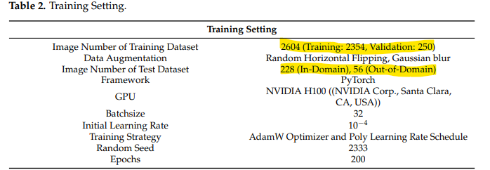
—Model Architecture and Training [Lyu et al. 2025]-
The network architecture follows a typical encoder-decoder structure widely adopted in semantic segmentation tasks.
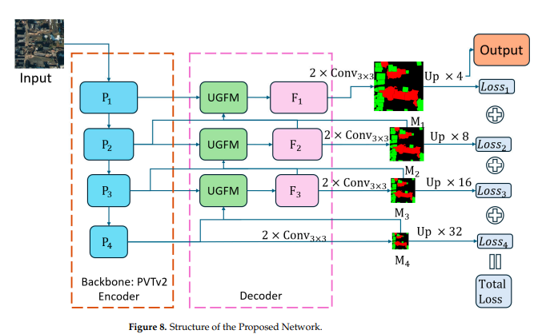
  - Encoder: In the encoder, employ a pretrained transformer-based backbone, Pyramid Vision Transformer-V2-B2 [Wang et al. 2021] (PVT-V2-B2), to extract hierarchical features across four stages (Pi, {i = 1, 2, 3, 4}) with channel dimensions of 64, 128, 320, and 512, respectively, ranging from low-level to high-level, from the input image;
  - Decoder: in the decoder, the highest-level feature P4 is first processed by two consecutive 3 × 3 convolutions to generate a coarse segmentation result M4. Subsequently, this lower-resolution result is transformed into an uncertainty map by the Uncertainty Guide Fusion Module (UGFM). The uncertainty map guides the feature fusion between low-level and high-level features, producing fused features (F, {i = 1, 2, 3,}) with channel dimensions of 64, 128, and 320, respectively. These fused features are then fed into two consecutive 3 × 3 convolutions, which are used to adjust channel dimensions and enhance the nonlinear representational capacity of the decoder to generate the segmentation result for the next stage.
  - This UGFM feature fusion process, followed by two consecutive 3 × 3 convolutions, is repeated at each stage until a final refined output with reduced uncertainty is produced (refer to Lyu et al. 2025).
  - Calculate the loss function: A hybrid loss combining Dice loss and Binary Cross-Entropy (BCE) will be used to balance accuracy and robustness in the presence of class imbalance (refer to figure 8)
  - Lightweight alternatives such as SegFormer-MiT-B1 or U-Net with EfficientNet-Lite may be used for edge deployments.
- Model evaluation; to assess the model performance, precision and recall were adopted as evaluation metrics.
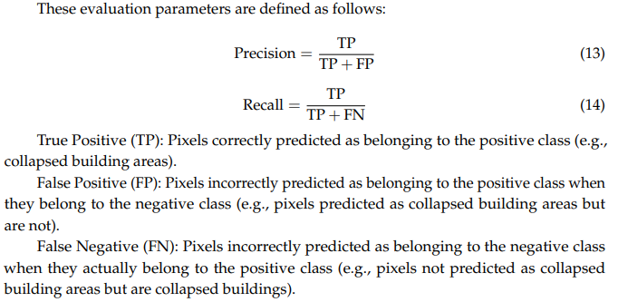
—Debris Quantification Workflow
The segmentation output will be post-processed to generate building-level debris estimates:
- Segmentation Output Aggregation: Collapsed building masks will be overlaid with building footprints to compute the collapsed roof area (A) for each structure.
- Volume Estimation: Debris volume (V) will be estimated as:
V=A×H_{col}×α
where:
  - H_{col}= collapsed height or building height × collapse fraction
  - α=compaction factor (typically 0.6–0.8)
When height data are unavailable, regression models calibrated from field data will estimate H_{col​} from roof area.
- Mass and Composition: The total debris mass will be computed using material densities and Waste Generation Rates (WGRs) associated with building type and construction material:
M_{i}=V×p_{i}×ρ_{i}
where p_{i} is the proportion of material i (e.g., concrete, metal, wood).
6. Model Evaluation
Model performance will be evaluated at both the pixel and building levels:
- Segmentation accuracy: Precision, Recall, F1-score, and mean Intersection over Union (mIoU).
- Volume estimation: Mean Absolute Error (MAE), Root Mean Square Error (RMSE), and Mean Absolute Percentage Error (MAPE) compared to field measurements.
- Material composition: Comparison of predicted vs. observed composition from sampled debris piles.
7. Field Validation Protocol- Not possible in our case
8. Outputs
The system will produce:
- GeoTIFF damage maps showing collapsed vs. intact structures.
- GeoJSON or Shapefile layers with per-building attributes: area, volume, estimated mass, and waste composition.
- CSV summaries for aggregation and reporting.
- Optional QGIS plugin or lightweight dashboard for visualization and data export.
9. Operationalization and Deployment
The final model will be optimized for both cloud-based processing and edge deployment.
- On high-performance servers: full-scale inference and map generation.
- On mobile or field devices: compressed models (ONNX/TFLite) enabling offline building-level assessments.
Outputs can be integrated into local municipal or humanitarian GIS workflows for rapid situational awareness.

References:
- Lyu, H., Oshio, H., Matsuoka, M. Deep Learning-Based Collapsed Building Mapping from Post-Earthquake Aerial Imagery. Remote Sensing. 2025,17,3116
- QGIS Development Team. Available online: https://qgis.org (accessed on 24 October 2024).
- Wang, W., Xie, E., Li, X., Fan, D.P., Song, K., Liang, D., Lu, T.,Luo, P., Shao, L. Pyramid Vision Transformer: A Versatile Backbone for Dense Prediction without Convolutions. In Proceedings of the IEEE/CVF International Conference on Computer Vision (ICCV), Montreal, QC, Canada, 10–17 October 2021; pp. 11–17

